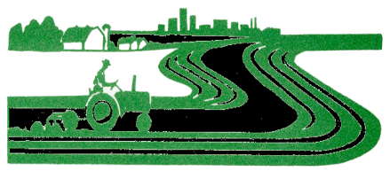
SHERIDAN COUNTY CONSERVATION DISTRICT

119 N. Jackson Street

Plentywood, Montana 59254
Phone: (406) 765-1801
Email: sheridancd@macdnet.org

Sheridan County Conservation District

Board Meeting

Wednesday, September 9th, 2020– 7:00 A.M.
Cousins Restaurant
AGENDA

- Call to Order
- Public Comment
- Approval of July 2020 Minutes
- Financial Reports & Bills to Pay for July & August 2020
- Other Reports
  - NRCS Reports – Brooke
  - Extension Report - Colleen
  - Field Report – Andrew
  - Administrator Report – Tahnee
- Unfinished Business
  - Permissive Mill Levy
  - Other
- New Business
  - Field Tech Position Opening
  - Other
- Pass Around File
- Next Meeting TBA
- Adjournment

